Friends of Hill Top Present
A Silent Auction
You can place a bid on the following items that were donated to school as prizes.
All of the donors have been contacted and agree to the auction.
The highest bidder wins!
Just complete the form, put it in an envelope by 16.07.2017 (Tuesday) return to school and
if your bid is successful you will be notified. You will need to come to the office to pay for your great day out.
You do not need to bid on all the days out, just the one(s) that you might like to win.
Please see voucher for exact expiry date but most of the vouchers expire at the end of the summer.
Donated by | Donation is worth | My Bid
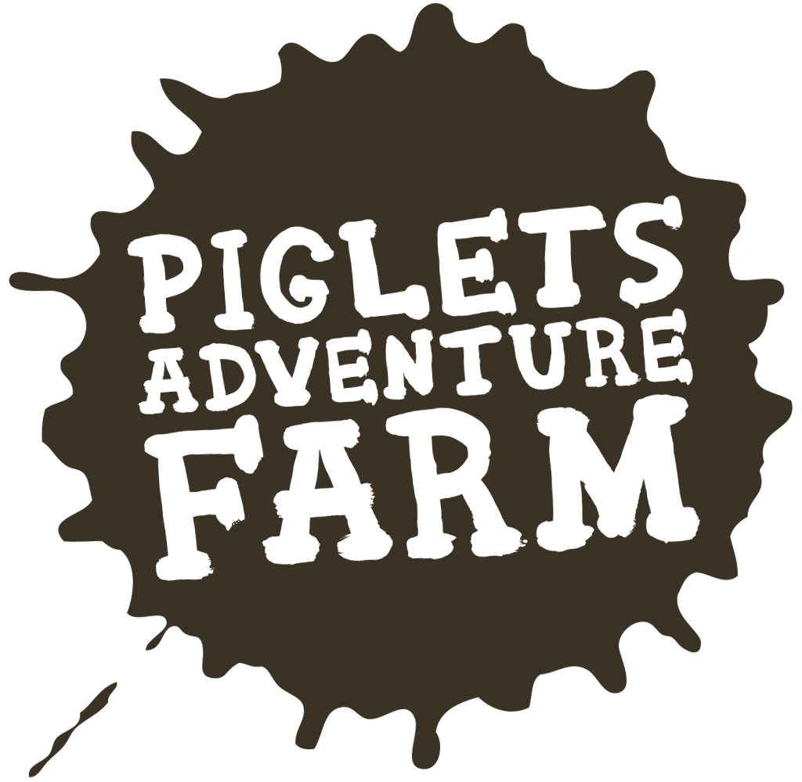  Family  Pass  for  Four | £36
Family of 4 voucher | £27.20
Family of 4 Ticket | £40
Family  of 4  Ticket | £35
Family of 4 Ticket  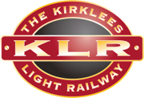 | £22

I confirm that I will pay my bid amount by the end of term (19.07.2019) if I am the highest bidder.

Child’s Name____________________________________________ Class________________
Telephone Number_____________________________________________________

You can either print this form or simply write on a piece of paper your bid and what you are bidding on. These must then go into a sealed envelope with ‘Silent Bid’ written on the front and should come in with the children. Winning bidders will be contacted on Tuesday.

