PRIZE | DONATED BY | WINNING NUMBERS
£50 VOUCHER | 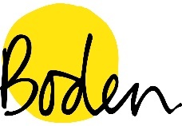 | BLUE GREY 571-575
£20 Voucher |  | PINK 916-920
Meal for 2 |  | BLUE GREY 516-520
Family Voucher |  | BLUE GREY 286-290
£10 Voucher |  | BLUE GREY 431-435
£25 Voucher |  | BLUE GREY 436-440  CLAIMED
£20 Voucher |  | GREEN 21-25
Meal for 2 |  | GREEN 101-105  CLAIMED
2 Cinema tickets |  | PINK 796-800
Family Voucher |  | PINK 776-780
Photography Voucher |  | BLUE GREY 111-115
Family Voucher |  | PINK 921-925
Small Hamper |  | PINK 846-850
Family Voucher |  | GREEN 26-30
Go Karting Voucher |  | BLUE GREY 376-380
£20 Voucher |  | BLUE GREY 476-480
Money Off Vouchers |  | PINK 991-995
2 Park Tickets |  | GREEN 36-40
Family Tickets |  | PINK 581-585
Family Swimming pass |  | BLUE GREY 451-455  CLAIMED

