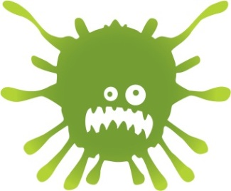
Final Nasal Flu Community Clinic

Nasal Flu Immunisations in Years 1, 2, 3, 4 and Reception

Did your child miss the flu immunisation programme in school?
This will be the last chance to obtain the Nasal flu vaccine – no more dates will be offered after this. Please ring to book an appointment for the following community clinic:
Tuesday 30th January 2018
3.30pm – 6.30pm (by appt only)

Armley Moor Health Centre
95 Town Street
Armley
Leeds
LS12 3HD

This is an appointment only clinic - please ring: 0113 8555224 to book an appointment
Please note: Flu immunisations can only be given to those children in Years 1, 2, 3, 4 and Reception who have missed the vaccine in school. No other age ranges will be immunised and will be turned away.

If you have any queries regarding the vaccination or the community clinic sessions, please contact the School Immunisation Team on 0113 8555224 or 0113 8555232.

